

Press Release

March 18, 2005

SEARCH LAUNCHED FOR THE NORTH WEST’S MOST INSPIRING ADULT LEARNERS

Do you know someone who has been bitten by the learning bug? Would their story and personal experience encourage other adults to find time to learn something new?

The hunt is on for the region’s most inspiring adult learners - as part of a campaign to highlight learning opportunities and the benefits of learning to individuals and communities across the North West.

Organisations and individuals are being encouraged to highlight and nominate family members, friends and colleagues for the prestigious ‘One Small Step’ Adult Learners’ Week Awards.

An awards’ ceremony at Urbis, in Manchester, on May 19 will act as a launch pad for Adult Learners’ Week (May 21 to 27).

The awards’ scheme is co-ordinated by MLA North West, the regional agency for museums, libraries and archives, in partnership with a number of other organisations that promote and advance all forms of adult learning.

More…
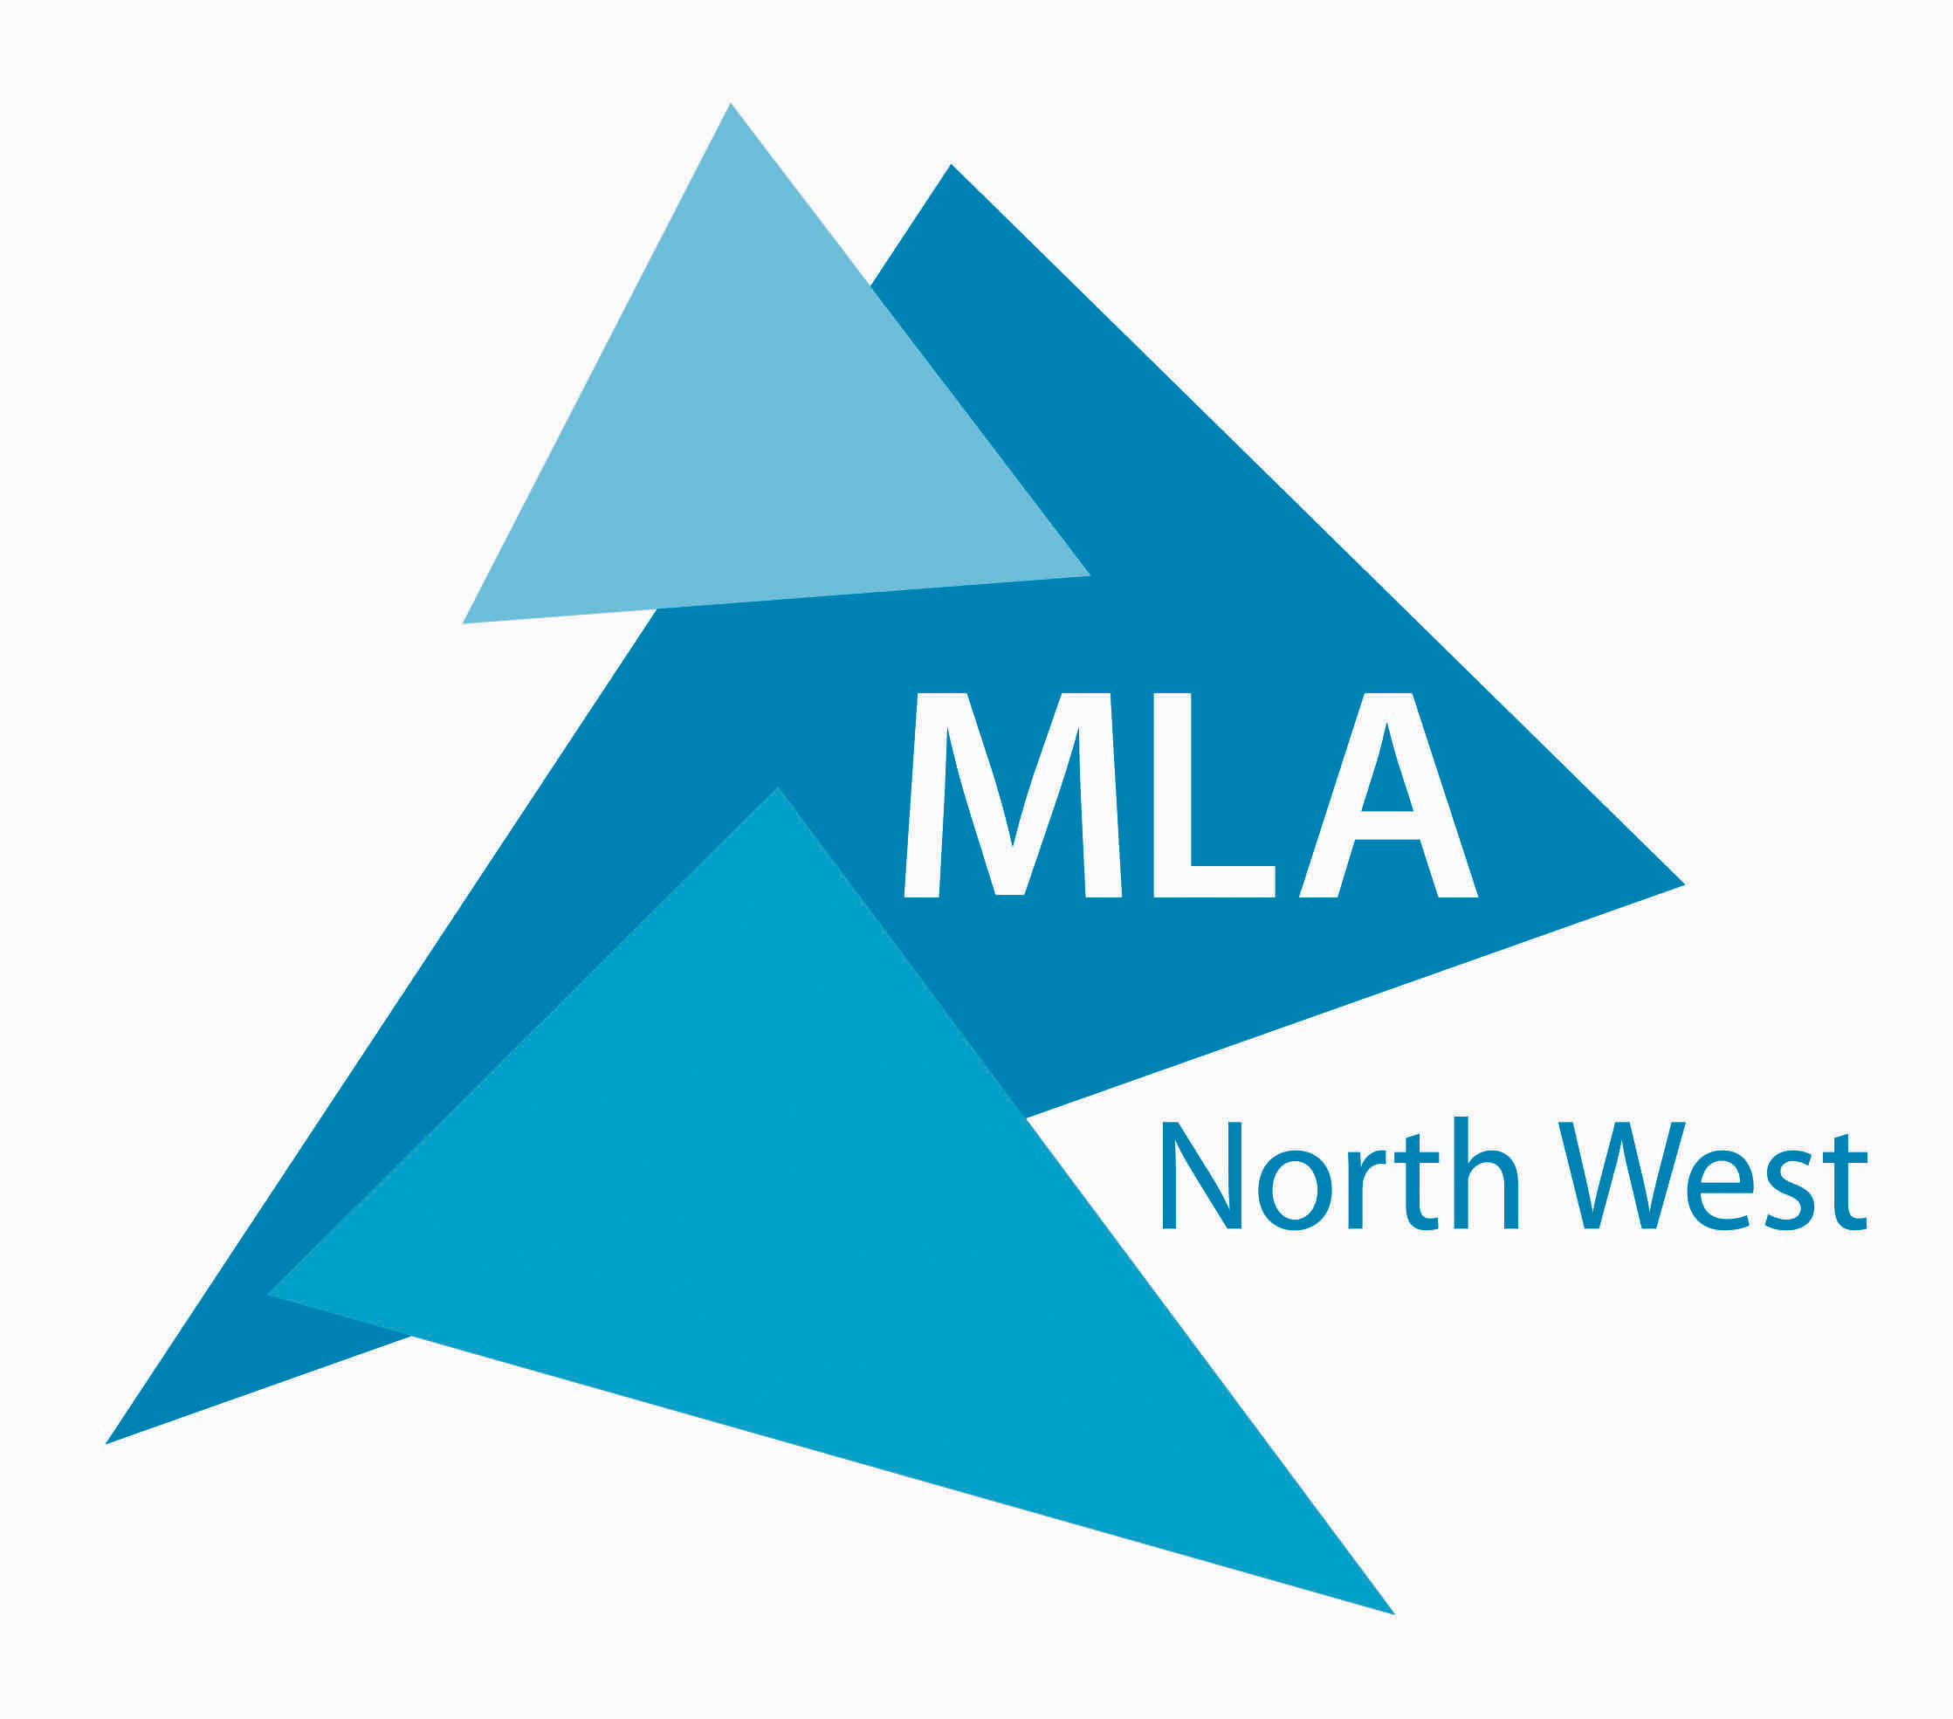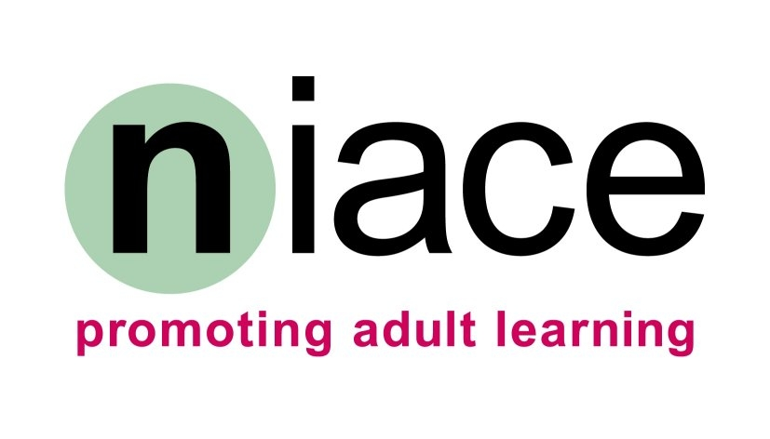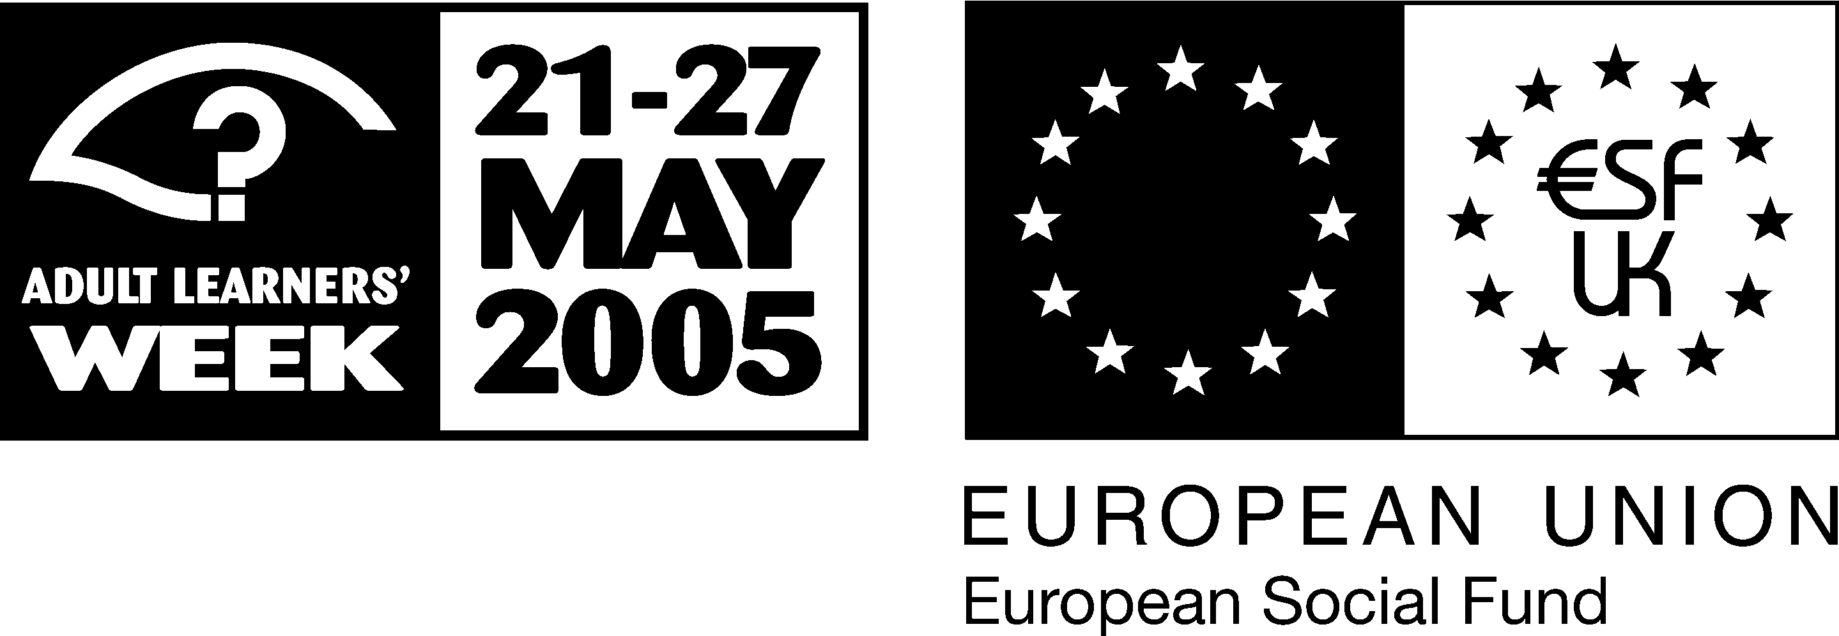

2/…

Several awards are available to individuals, including special awards for NHS learners, basic skills students, over 50s learners and anyone learning with the support of regional museums, libraries and archives. There are also awards for organisations and volunteers who enrich the experience of learners by providing information, advice and support - and help `make learning happen’.

The awards are open to anyone from the North West, aged over 19, who has been involved in formal or informal learning - whether for personal, professional or academic development, or simply for pleasure - during the past 12 months.

Claire Connor, Chief Executive of MLA North West, said: “These awards celebrate the achievements of the region’s learners - people who find the time and creativity to learn something new every year, and whose stories provide the inspiration to encourage others to try learning for themselves.”

Last year’s award winners ranged from a 73-year-old postgraduate student - described as ‘unbearable’ when he’s ‘without study’ - to a 33-year-old single mum who returned to education in order to lay the foundations for a career in occupational therapy.

The awards’ scheme is delivered in partnership with the National Institute for Adult Continuing Education (NIACE) and the BBC, and is sponsored by the Greater Manchester Strategic Health Authority, Manchester Basic Skills Consortium, Learning and Skills Council Greater Manchester and the Manchester Life Long Learning Partnership.

More…

3/…

The closing date for nominations is April 22, 2005. Full details about the award categories, and nomination forms, can be found on the MLA North West website, at www.mlanorthwest.org.uk - or call 01925 625050 for details.

Ends

For media enquiries, please contact Lindsey Shaughnessy or Dave Weston at Staniforth on 0161 274 0138 or 0161 274 0117 – email lindsey.shaughnessy@staniforth.co.uk or david.weston@staniforth.co.uk

Notes to Editors
- Adult Learner’s Week is an opportunity to celebrate, promote and advance all forms of learning. It is coordinated nationally by NIACE (the National Institute of Adult Continuing Education) and core-funded by the Department for Education and Skills, the European Social Fund and learndirect.
- Adult Learner’s Week is an opportunity for organisations that offer any form of adult learning activity to present a special promotional activity, or to label their existing activities as “Adult Learners Week”
About MLA North West
- MLA North West is committed to developing accessible, inclusive
- collections and services that provide lifelong learning, inspiration and enjoyment for all.
- MLA North West provides innovative services and strategic leadership for the region’s 160 museums, 40 major archives and 500 libraries.
- MLA North West’s aim is to maximise the contribution this sector makes to the North West’s cultural, educational and economic prosperity.
- MLA North West is one of nine regional agencies in the UK tasked with the promotion and development of the sector nationwide.

