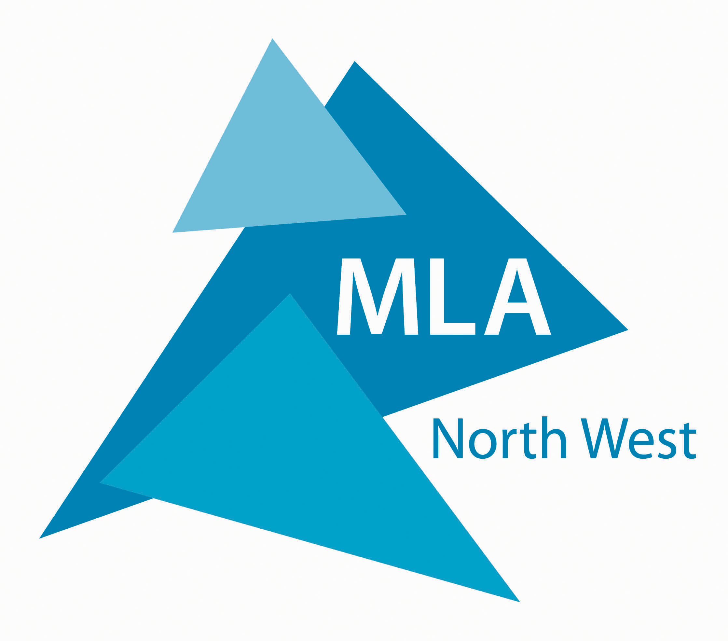

RISING STARS VI
MANAGEMENT DEVELOPMENT PROGRAMME

MLA North West, working in partner-ship with NTS Developing People Ltd, is able to offer 15 places on a dynamic five month management development programme that offers a unique opportunity for a group of staff from across the domains. The programme is targeted towards staff at middle management level, with some staff and budget responsibilities, who aspire to senior management and leadership roles. MLA North West is offering these places free of charge.

Director/Senior Manager support and input into the programme is a requirement.

The venue for all sessions is Forrest Hills, just outside the city of Lancaster.

If you have any queries or wish to discuss the programme, please contact Chris Chadwick, Head of Development, MLA North West, tel: 01925 625053 or
e-mail: chris.chadwick@mlanorthwest.org.uk.
PROGRAMME 2006
Module 1
Understanding People and Managing Performance
Session 1  9 February |  | Induction: Understanding Yourself and Others
Session 2  16 February |  | Performance Management
Session 3  2 March |  | Feedback and Coaching
Module 2
Leadership and Followership
Session 4  23 March | Enabling Creativity and Innovation
Session 5  30 March | Leadership and Team Working
Session 6  27 April | The Leadership Challenge
Module 3
Policies, Plans and Performance
Session 7  4 May | Strategy and Marketing
Session 8  18 May | Finance: Budgets, Bidding and Partnerships
Session 9  25 May | Performance Measurement and Evaluation
Session 10  8 June | Project Management
Session 11  15 June | Tutorial Day
Session 12  22 June | Presentation Day

---------------------------------------------------------------------------------------------------------------------

RISING STARS VI - MANAGEMENT DEVELOPMENT PROGRAMME
I would like to apply for a place on the Rising Stars VI programme and have enclosed my CV and a short covering letter explaining why I would like to join the programme.
Name:
Organisation:
Address:
Tel no:
Email:
Name of Line Manager/Director:
Signature of Line Manager/Director:

Applications should be submitted to Chris Chadwick, Head of Development, MLA North West, Ground Floor, The Malt Building, Wilderspool Park, Greenall's Ave, Warrington, WA4 6HL or by email to adminpost@mlanorthwest.org.uk no later than Wednesday 11 January 2006.

