Leading Archives and Museums

Dear colleague

We are delighted to tell you that following successful pilots, MLA and its partners have secured funding to enable revised Leading Archives and Museums programmes to run in 2006-7.

This represents a superb opportunity for managers in museums and archives to develop their leadership skills. The focus of the programmes is on aspiring leaders (Future Leaders Programme) and mid-career managers (Senior Managers Programme). The structure and content of the programmes are unique and are designed to complement other opportunities in the cultural sector, available both regionally and nationally.

Please find a brochure enclosed which has full details of each programme.

MLA has agreed to fund the following places on these programmes, in your region:

- 2 places on the Future Leaders Programme
- 1 place on the Senior Manager Programme

To apply for places, complete and return the enclosed Nomination Forms as soon as possible. We would be grateful if you could read the Guidance Note before completing the Nomination Forms.

If your nomination is successful, we will invoice your organisation directly for the places (£2,000 plus VAT for each Future Leader place and £3,000 plus VAT for each senior manager place). You will, however, be able to reclaim these amounts in full, via an MLA grant. We will advise you of how to do this, at the same time as issuing the invoice.

We look forward to working with you on this exciting programme.

Yours sincerely

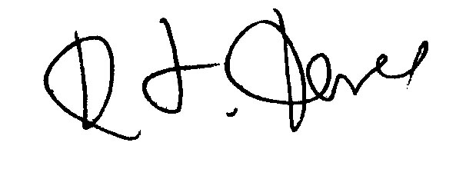
Kevin Ford
Chief Executive, FPM

PS For more brochures and/or forms, don’t hesitate to contact us on 08702 406 206, or visit www.fpmonline.co.uk.

