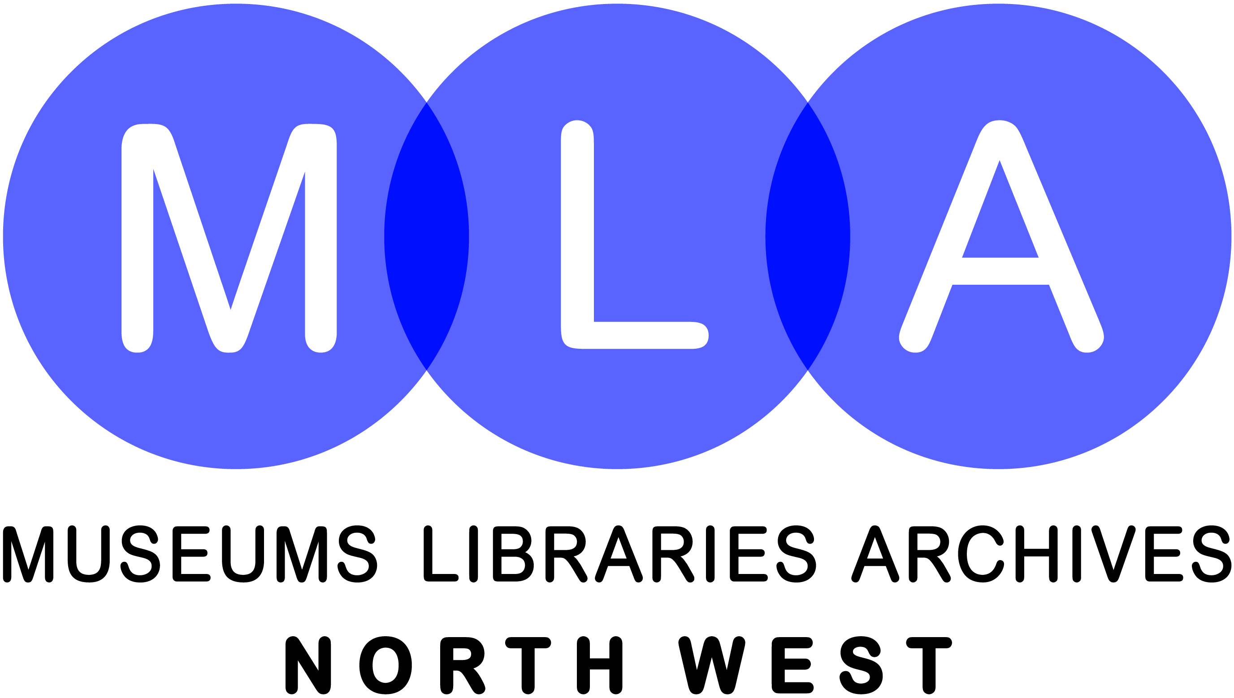
MLA North West

Case Study Submission Form

Introduction
MLA North West would like to capture information about your organisation’s work which could be of interest to the sector, stakeholders and key funders.

Our aim is to share good practice and information about the range of services and activities available in the sector. By promoting and developing the services offered by museums, libraries and archives in the North West, we hope to inspire other organisations to undertake innovative projects of their own.

Your case study may be made available to other museums, libraries and archives, via the MLA North West website and publicity materials.

Permission
By submitting this case study, I give permission for any or all of the information herein to be posted on the MLA North West website and used in publicity materials.

I understand that, once submitted:
- the information may be published on MLA North West’s website
- copyright of this information will pass to MLA North West
- discretion of released materials lies with MLA North West

Thank you very much for your help!

Contact Details
Name:
Organisation Name & Address:

E: T:
W:
Alternative Contact Details
Name:
Organisation Name & Address:
E: T:
W:
Section 1
The questions in this section aim to communicate the unique selling points and outcomes that have made a life changing impact on the projects participants and identify the resulting long term benefits for future audiences.

Consider each question’s guidance notes before answering in narrative form (max 150 words)

Project title | e.g. “Find out how I increased the number of school visits to the museum”

What was the initial aim of the project? | Who was the project for and why did they need this?  (bullet point objectives)

What did you do to achieve your goal? | How did you consult, work towards the aims and evaluate your work? Which resources did you use? What processes did you put in place etc… Try to be concise – reflect and focus on those elements that make your project stand out from similar projects.

Project website address | If your project has a website enter the web address here.

Which organisations helped you achieve your goal? | Copy here the links to the website of organisations that helped you to achieve your goal (e.g. www.businesslinks.org.uk)

Funding | What was the estimated budget for the project?
 | What was the final budget for the budget?

What would you have done differently? | Is there anything that didn’t go as expected, or that you could have avoided?

What would you do the same? | Is there anything that helped you achieve your goal? What evidence do you have from your evaluation of beneficial impact? Will the project be continued or rolled out? Has it lead to recognition or further opportunities?

Your tips and tricks | Taken from successes and difficulties, prioritise three tips would you give to someone who is planning a comparable project?

What was the start date of the project? | Dates should be entered using the following format…  e.g. January 2006
What was/is the end date of the project? | Dates should be entered using the following format…  e.g. January 2006

Section 2
In each of the remaining sections, please indicate, by marking with an ‘x’, all of those categories which relate to your project.

Audience

Disadvantaged/ Excluded Groups
Carers  Prisoners  Sheltered housing residents  Refugees & asylum seekers  Young offenders |  | Looked after children  Unemployed people  Homeless  Travellers
Social Groups
Rural communities  Volunteers in MLA’s  Sheltered housing residents  Staff in MLA’s  Health clients |  | Reading groups  Parents  Urban communities  Families  Non-user
Gender
Male |  | Female
Ethnic and National Groups
Black Africans  Black Caribbean’s |  | Asian ethnic groups  Ethnic minorities
Disability
Mental health clients  Hearing impaired people  Visually impaired people |  | People with mobility difficulties  People with learning difficulties
Education and Learning
Early years  Schools KS1  Schools KS3  Teachers  Further and higher education |  | Schools 1619  Schools KS2  Schools KS4  Young people in information learning
Age
Children  Adults  Young people 14-25 |  | Teenagers  Older people
Section 3
Outcomes/ Themes

Access
Access policy  E-government  Intellectual access  Sensory access (hearing) |  | Digital citizenship  Emotional access  Physical access  Sensory access (visual)
Communities
Artists in residence  Community projects  Family history  Oral history  Reminiscence |  | Citizenship  Creativity  Local history  Reader development
Diversity and social inclusion
Cultural diversity  Numeracy |  | Literacy  Social inclusion
Health
Health related issues
IT
IT related issues
Education
Lifelong learning  Study support  Family learning  Teacher training |  | Basic skills  Education policies  National curriculum
Marketing and Promotion
Audience development  Evaluation  Market research (nonuser)  Market research (quantitative)  Marketing  Public relations |  | Customer care  Interactives  Market research (qualitative)  Market segmentation  Marketing communications  Public relations
Regeneration
Neighbourhood renewal |  | Economic regeneration
Workforce Development
Reskilling |  | Staff development and reorganisation
Volunteer work |  | Work skills

Section 4
The Sector

Sector
Archives  Museums  Historic environment  Natural environment |  | Libraries  Cross-domain institutions  Galleries  Other cultural and heritage institutions
Type
School  Local/regional government  Pan-government  Commercial/industrial  Learned society  Trade unions  Other  Armed services  Research institutions |  | Further and higher education  Central government  Other public body  Professional/trade association  Charity  Cooperative  Independent  Galleries  Media

Section 5

Programmes

Programmes
Archives development programme  Cultural entitlement  E-society  Inspiring learning for all  Leadership and advocacy  Literature matters  Pay and power  Renaissance in the regions  Vital link |  | Collections development  Cultural hubs  Framework for the future  Investing in knowledge  Learning and access  New directions  People’s Network  Routes to knowledge  Workforce development

Please email completed submissions to info@mlanorthwest.org.uk

