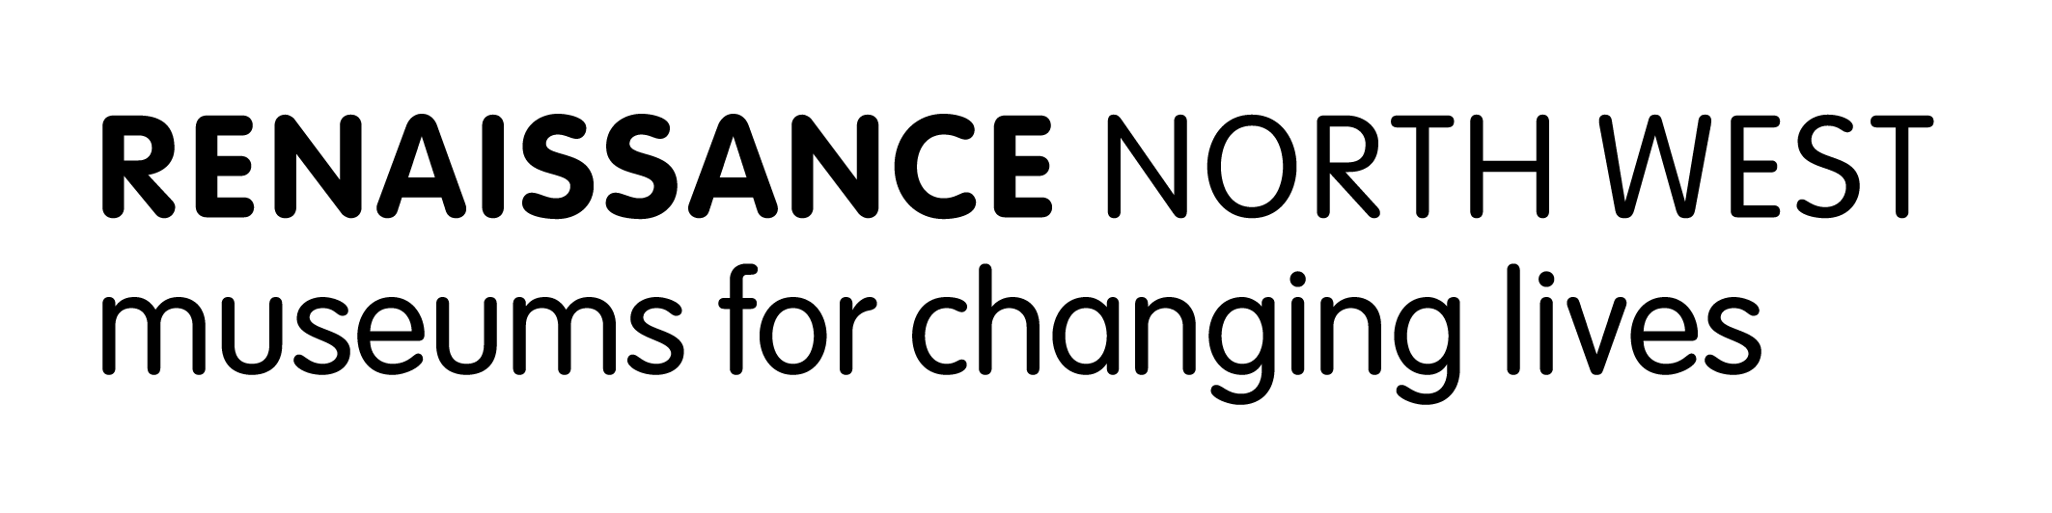


‘Unleash the power of your collections!
Collections for the Future Challenge Fund 2007 – 2008

Grant Application Form
Please read the Renaissance North West Collections for the Future Challenge Fund 2007 – 2008 Guidelines before applying and provide as much relevant information as possible. If you have any queries, please contact Catriona West, Development Officer (Renaissance) Tel: 01925 625056 catriona.west@mlanorthwest.org.uk

- Contact Details of applicant:

Organisation
Registered / Accredited Status
Address
Contact Name
Position
Email
Telephone

- Is this a Cross-Domain project?
For Office Use Only:

Amount
Requested:

Yes

No

- Details of partner organisation(s) (if applicable)
If your application is for a partnership project, please list here the details of the partners:
Lead Contact | Partner  Organisation(s) | Telephone | E-mail
1
2
3

Project Proposal

- Title and Brief Description of your project
Title
Brief Description

- What activity will take place (Maximum 250 words)

- Please demonstrate how your project will enable increased access to collections as outlined in the Collections for the Future Challenge Fund Guidelines. All projects must demonstrate how users will benefit and how access to collections will be increased, in particular to unknown or underused parts of collections that may be currently in store, in loan collections or on display

- How do you plan to evaluate your project?

- What is the timescale for the project?

Financial

- What is the total cost of the project? £
- How much grant are you applying for? £
Match funding is not essential

- Breakdown of the project costs:

Please give an estimate of the main elements of expenditure. Give full details of financial assumptions and calculations, e.g. salary/grading structure used, materials, suppliers, evaluation costs, etc.
Budget Headings | Amount
Total cost of Project | £

If you are receiving any match funding?

How much? | £
Where is this funding coming from?
Has it been confirmed?

- DECLARATION

I declare that I have read and accepted the terms and conditions attached to Renaissance North West, Collections for the Future Challenge Fund, and that the information provided in this application is correct to the best of my knowledge.

Name ................................................................................................................

Position .............................................................................................................

Signature .............................................................. Date .................................

Please return your forms to:
Catriona West
Development Officer (Renaissance) Tel: 01925 625056
MLA North West Fax: 01925 243453
Ground Floor catriona.west@mlanorthwest.org.uk
The Malt Building
Wilderspool Park
Greenalls Avenue
Warrington WA4 6HL

Deadline: 5.00pm Thursday 10th May 2007

Applications can be received by email by the deadline but a signed hard copy must also be sent before we can release funds.

